Open your site with this path _layouts/savetmpl.aspx and make your template. Your template will be saved as wsp…

Make a sub site with this template.

If sub sites ui is damaged then save template wsp file to your system and change it extension to cab/cap. A zip file will show go in there and find onet file. Edit it with notepad++ and remove sub all nav bars except 1 as shown.

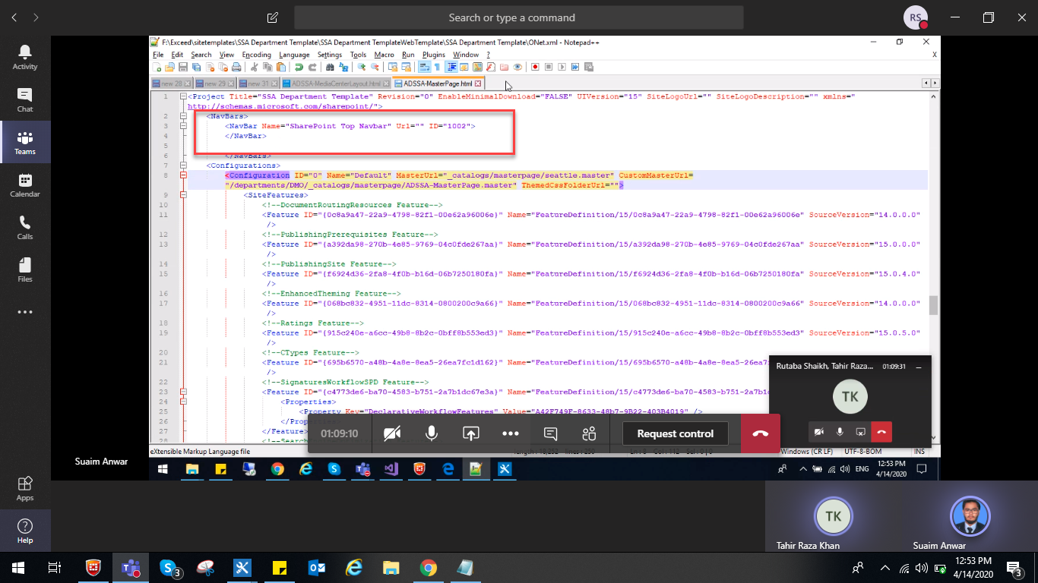

And paste url of master page path from designer in custom url page as shown

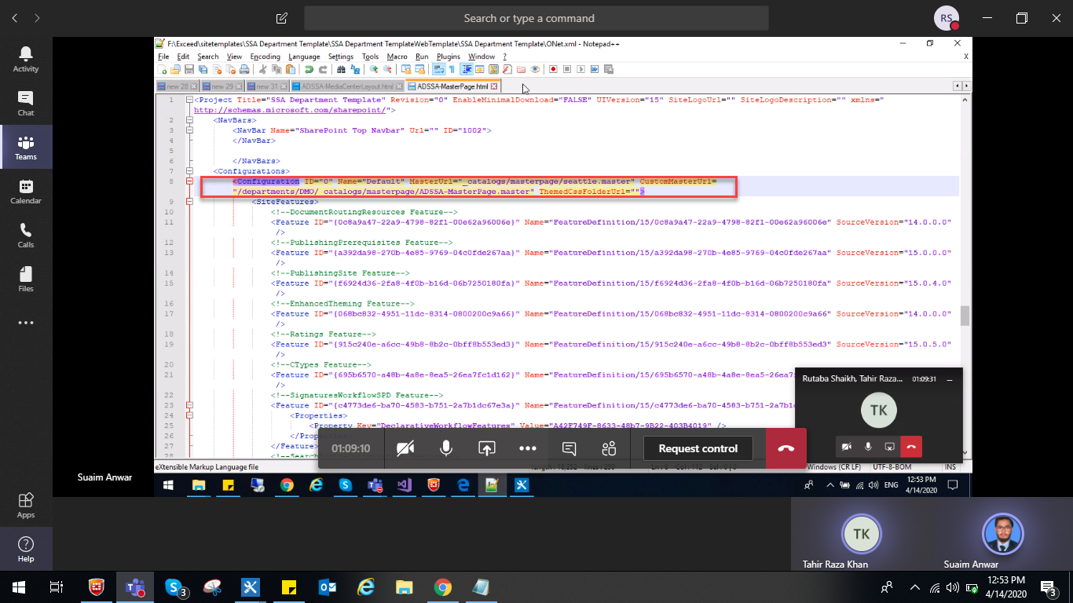

Save this file and convert it to wsp file with cab maker.

Deactivate your previous wsp and delete it and upload yours from file explorer and make sub site with this template.